# Project Design Phase

## Solution Architecture

Date: 15 February 2025

Team ID: LTVIP2025TMID45799

Project Name: TrafficTelligence – Advanced Traffic Volume Estimation with Machine Learning

Maximum Marks: 4 Marks

## Solution Architecture:

Solution architecture is a complex process – with many sub-processes – that bridges the gap between business problems and technology solutions. Its goals are to:  
• Find the best tech solution to solve existing business problems.  
• Describe the structure, characteristics, behavior, and other aspects of the software to project stakeholders.  
• Define features, development phases, and solution requirements.  
• Provide specifications according to which the solution is defined, managed, and delivered.

Architecture Diagram:

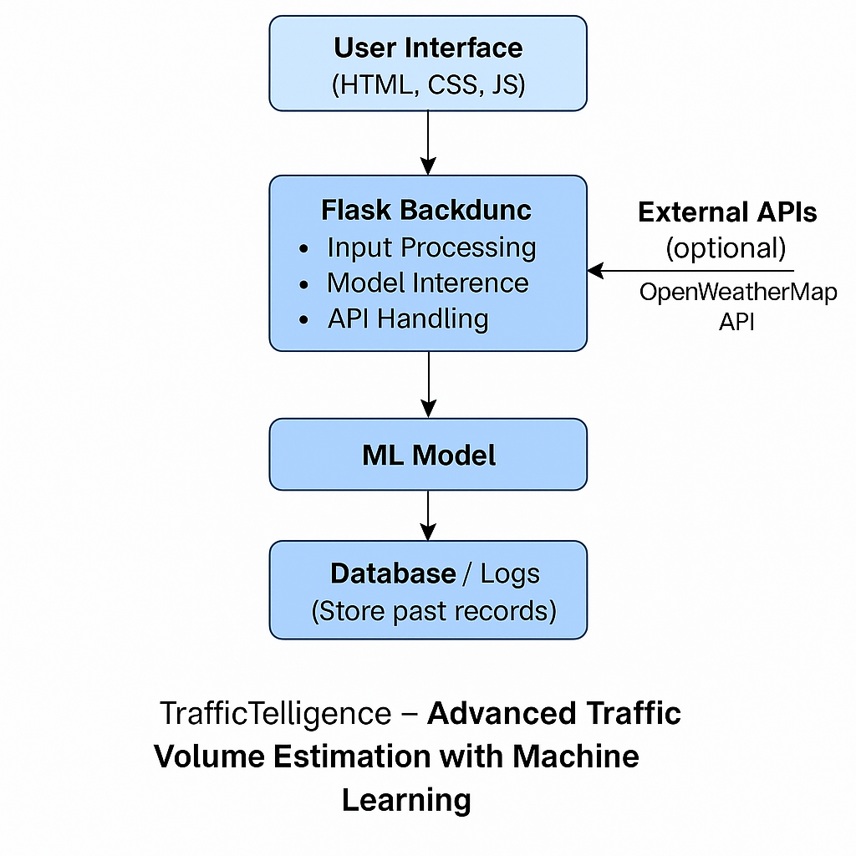Figure 1: Architecture and data flow of the TrafficTelligence application.